Swaziland

## Respect for rule of law (ROL) data

The data set shows the data on the respect of the rule of law for the country.

## # A tibble: 19 x 5  
## country iso3c date ruleOfLaw ruleOfLawCategory4   
## <chr> <chr> <dbl> <dbl> <chr>   
## 1 Swaziland SWZ 1996 -0.474 ROL moderately disrespected  
## 2 Swaziland SWZ 1998 -0.534 ROL moderately disrespected  
## 3 Swaziland SWZ 2000 -0.599 ROL moderately disrespected  
## 4 Swaziland SWZ 2002 -0.670 ROL moderately disrespected  
## 5 Swaziland SWZ 2003 -0.734 ROL moderately disrespected  
## 6 Swaziland SWZ 2004 -0.866 ROL moderately disrespected  
## 7 Swaziland SWZ 2005 -0.901 ROL moderately disrespected  
## 8 Swaziland SWZ 2006 -0.677 ROL moderately disrespected  
## 9 Swaziland SWZ 2007 -0.756 ROL moderately disrespected  
## 10 Swaziland SWZ 2008 -0.646 ROL moderately disrespected  
## 11 Swaziland SWZ 2009 -0.622 ROL moderately disrespected  
## 12 Swaziland SWZ 2010 -0.529 ROL moderately disrespected  
## 13 Swaziland SWZ 2011 -0.494 ROL moderately disrespected  
## 14 Swaziland SWZ 2012 -0.494 ROL moderately disrespected  
## 15 Swaziland SWZ 2013 -0.459 ROL moderately disrespected  
## 16 Swaziland SWZ 2014 -0.314 ROL moderately disrespected  
## 17 Swaziland SWZ 2015 -0.324 ROL moderately disrespected  
## 18 Swaziland SWZ 2016 -0.368 ROL moderately disrespected  
## 19 Swaziland SWZ 2017 -0.290 ROL moderately disrespected

## Respect for rule of law (ROL) trend

The plot shows the trend of the respect for the rule of law for the country.

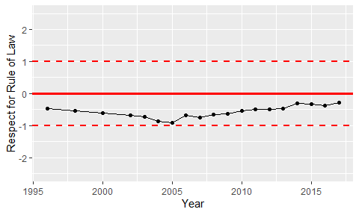

Trend of the Respect for the Rule of Law